1. What to write about exactly for the extension?

Discuss images and data, and what is being done.

Just talk about application

Keep in aything that will impressive, educating and communicating research,

Mundane is not necessary

* 1. Should the method of the opencv functions be explained?
     1. ie theory how how and why each are used?

Intro

Background

Data acquisition

Determining texture quality and surface statistics

Image Object Detection

General Approaches for Object Detection

Intro

Object detection is one of the classical problems of computer vision and is often described as a difficult task. In many respects, it is similar to other computer vision tasks, because it involves creating a solution that is invariant to deformation and changes in lighting and viewpoint. What makes object detection a distinct problem is that it involves both locating and classifying regions of an image [20]. The locating part is not needed in, for example, whole image classification

Image Object Detection

General Approaches for Object Detection

The template matching technique it is conceptually a simple process.Fundamentally,it tries to find a location of an object,basedon its template,on an image by the match of the template.(Aljarrah & Ghorab, 2012)

Hough transform

egion basedThis technique starts by transforming the original image, that comes as an input, into a directed graph, whichis builtbased on variousdefined rules. The characteristics of the graph represent the global shape informationofthe object in the input imageand are extracted while the graph is being constructed.(Latharani et al., 2011)

Data

Method

Data Preprocessing

Once an image has been acquired, pre-processing algorithms can be applied to improvethe image quality, for example to highlight important features or to remove noise (Gon-zalez et al., 2004). Examples of noise reduction can include blurring of an image toreduce noise produced by randomness in the world or the sensor, or scaling the imageto reduce the impact of individual pixels which differ greatly from their immediateneighbours. Image sharpening to increase the prominence of edges and other texturedetails can be used on its own or in combination with blurring for noise reduction. Thechoice of colour space can also affect how clearly individual features can be detected.The choice of colour space is a major part of preprocessing. Colour is an interpreta-tion of the frequencies and amplitude of a light wave. The human eye interprets thesefrequencies in the red, green and blue frequency ranges. Depending on the task, it canbe preferable to interpret light using a different colour model. Several colour modelsand their applications are described below.The RGB colour space is based on the principle that every visible colour can beproduced from a mix of the three primary colours of red, green and blue, inspired by thecolour-sensitive cells in the human eye. Used for producing colour images in computermonitors by means of red, green and blue light sources, this has become a popularcolour model in computer imaging as it does not need converting to display on screen.The colour model can also be normalised in order to remove the brightness element.This is done by turning the absolute values into fractions totalling 1.r=RR+G+B,g=GR+G+B,b=BR+G+BThe HSI colour space uses the three channels hue, saturation and intensity. Thesechannels represent concepts that are easy for a human to understand. The hue, whichrepresents the dominant frequency of the light, is referred to as the pure colour, whilesaturation represents the amount of white light mixed in with the pure colour and theintensity represents the overall brightness of the colour (Gonzalez et al., 2004)

Iltering

clean up the results with various filters and pre or post processing techniques. Thetechniques I tested, both before and after using the classifier, include smoothing,dilation, erosion, and contour approximation. The goal of these techniques is toclean up the resulting binary image for the best possible estimation of the locationof the buoy.The first such filter I tested was a smoothing algorithm, which attemptsto smooth the edges of objects in the image. The OpenCV library provides asmoothing function, which can use different smoothing techniques such as Gaus-sian or Median blur. The Gaussian blur convolves each point with a Gaussian

22kernel to produce the output array. The Median blur replaces each pixel by themedian in a neighborhood of the pixel. The Median blur is used in this experi-mentation. Smoothing the image prior to using the boosting classifier causes extrapositive pixels, which in turn causes more noise and increased size of connectedcomponents, or blobs. Doing the smoothing after the boosting classifier more ac-curately captures the location of valid objects. The resulting blobs, such as thoseseen in Figure 3.4, simply output with smooth edges as seen in Figure 3

Cantre estimation

Once the algorithm has processed an image and output a binary image withsome number of blobs, the next goal is to determine which blob is the most likelyto be the buoy, and then find its center. In the baseline algorithm, the centerestimation was simply the centroid of the binary image in terms of positive pixels.Figure 3.2 exemplifies this form of center estimation, since the green circle in thecolor image is estimated between the two blobs.

Sehementstion

mage segmentation is a method of partitioning an image into regions that have a strongcorrelation with objects or areas of interest (Brosnan and Sun, 2004). In this thesis,these areas are the potato and background areas. Unay and Gosselin (2006) provideanother example, where the stem and calyx, or flower, of apples were segmented inorder to remove them from consideration by a classifier which distinguished betweengood and bad apple skin.Three of the more common types of segmentation are, thresholding, edge-based andregion-based segmentation, as shown in Figure 2.2.Thresholding is a simple form of segmentation. From a greyscale image, threshold-ing can be used to create binary images (Gonzalez et al., 2004). This can be one of14

2.2 Overview of computer vision systems for food product analysisthe fastest segmentation algorithms, since it does not require any additional prepro-cessing. Edge-based segmentation involves the detection of discontinuities in the greylevel, colour or texture of pixels. Region-based segmentation involves the groupingtogether of similar pixels to form regions representing single objects within the image.The criteria for like-pixels can be based on grey level, colour and/or textu

Feature extaction

feature, also referred to as a descriptor, refers to an abstrac-tion of image information which represents individual measurable heuristic propertiesfor recognising some phenomena present in that image or a region within that image(Gutierrez-Osuna and Hierlemann (2010), IBM (2012)). Features extracted from digi-tal images can include information relating to the colour, texture and shape of an objectof interest. These features may be summarised statistically, such as by a histogram orthe statistical moments (mean, standard deviation, skewness, etc.) of a feature valuemeasured for individual pixels over a region of interest. Such “region features” can

Hough TransformThe next two versions of the algorithm add a step utilizing the HoughTransform algorithm, which is designed to find straight lines in an image. Theinputs to this algorithm are important in deciding how conservative or liberal thealgorithm should be in its search for straight lines. The first two inputs to thealgorithm are Rho and Theta, which represent the granularity of pixels and theangle for scanning the image. With a low Rho and Theta, the search will considermore possibilities in its search, finding more of the lines present, but taking moreprocessing. The next value is Threshold, which is how long in pixels a straight lineneeds to be in order to return as a line.

Feature SelectionWhen classifying data with a high number of available features, it can become necessaryto find ways to reduce the number of features which the classifier has to process. Thisis because every additional feature increases the complexity of the classification. Mostmethods of reducing the number of features either work by selecting a subset of featuresfrom a larger candidate feature set, while others such as principal component analysis(PCA) produce a smaller feature set composed of mathematical functions of the originalfeatures (Forsyth and Ponce, 2

ResultsDataset Statistics

Discussion

Document all challenges and how they were overcome with a clever solution

Can be included in any way in the report (interesting or any challenges)

4. Application: Moth-eye SEM image anlaysis (6 pages)

1. Overview

Conventional measurement techniques used for the checking, often called characterization, such as mechanical proﬁlometry and optical microscopy, are already reaching their limit in resolution. Novel techniques including atomic-force microscopy, scanning-electron microscopy, and near-ﬁeld microscopy, although they are feasible, require expensive equipment with high maintenance costs. Furthermore, they are inherently slow methods that require tedious preprocessing of the sample. There- fore they are usually not suitable for the fast on-line characterization that is required in dynamic indus- trial environment

2. Data

Nomial data

3. Approach

List filters:

* grey
* bilateral
* ect
* example

3. Results

4. Discussion

Moth and butterfly ommatidial nanostructures have been extensively studied for their anti-reflective properties. Especially, from the point of view of sub-wavelength anti-reflection phenomena, the moth eye structures are the archetype example

Nature has been an inspiration for humans since centuries. Various structures available as a creation of nature surprise us even today. For example, the colors exhibited by the butterfly wings are a subject of intense curiosity and research studies for few decades.[(1−7)](javascript:void(0);) They have caught the eyes of humans by surprise due to the variety of colors exhibited by the wings. Another important aspect is the design of their eyes with minimum reflection and also enables them to reflect ultraviolet and polarized light.[(8,9)](javascript:void(0);) One of the earliest experimental works done on the classification of insect species based on nipple height and arrangement showed that the nipples are hexagonally arranged with height variation between 50 and 250 μm. This study suggested that the varied height of corneal nipples in different species indicate the evolutionary development and diversification.[(10)](javascript:void(0);) Hexagonal arrays on cicada (e.g., *Psaltoda claripennis*) and termite (e.g., family Rhinotermitidae) wings have been investigated. The study reveals that the structures have spacings that vary between 200 and 1000 nm with rounded shape protruding out about 150–350 nm from the surface.[(11)](javascript:void(0);) Recently, the scanning electron microscopy study on the corneal nipple nanostructures of diurnal butterfly species indicated more intricate hexagonal packing with multiple domains. Here also, the spacing between the nipples ranged between 180 and 240 nm and the height varied between 0 nm (papilionids) and 230 nm (nymphalid).[(12)](javascript:void(0);) It has been assumed that both the butterflies and moths have color vision and the precise method of color vision is not fully understood yet. In this regard, extensive research has been undertaken to understand the moth eye structure, image formation, and image processing in the eyes of butterflies and moths.[(12−14)](javascript:void(0);) To understand the function of these corneal nipples, several theories have been put forward. The most commonly used theory indicates the reduced reflection of light by the corneal nipples, thereby increasing the amount of light captured.[(15)](javascript:void(0);) Another theory suggests that these corneal nipple arrays reduce the eye glare, thus saving themselves from the predator.[(12)](javascript:void(0);) It is also suggested that the moth eyes are evolved in such a way that the nanostructured corneal nipple array reduces the adhesion due to a reduction in the contact area of contaminating particles.[(16)](javascript:void(0);) Since there is no correlation between the type of nanostructure and the evolutionary stage of the group, the various categories belong to a diverse set of Turing patterns.[(13)](javascript:void(0);)

The anti-reflection properties have been studied by coating nanostructured materials on surfaces (both hard and flexible) and understanding the absorption and transmission properties of these coatings.[(17−26)](javascript:void(0);) The tiled sub-wavelength nanostructures also reduce the iridescence caused by the diffraction of light incident at high angles.[(27)](javascript:void(0);) This phenomenon is modeled by considering different shapes of nipples (pillars, parabola, and cones).[(28,29)](javascript:void(0);) Recently, by employing self-assembly of polymer and then plasma etching, scientists have fabricated moth eye structures to enhance the broadband anti-reflection in silicon solar cells.[(30)](javascript:void(0);) Such sub-wavelength nanostructures will show broadband anti-reflection over a wide angle of incidence when the height is more than ∼0.4λ and spacing *l* ≈ *λ*/2*n*s, where *n*s is the refractive index of the substrate.[(31)](javascript:void(0);) Currently, the material nanostructures can be precisely controlled by means of fast-improving nanofabrication techniques. Better anti-reflective structures have paved the way for advanced manufacturing of moth-eye structures for various applications such as solar cells,[(32)](javascript:void(0);) light-emitting diodes,[(33)](javascript:void(0);) and display screens.[(34)](javascript:void(0);) In this direction, the analysis of chitin nanostructure in the eyes of butterflies and moths needs to be understood in detail.[(35−38)](javascript:void(0);)

In the case of moths and butterflies, moths are active in the night (nocturnal) and the butterfly is active during the day time (diurnal). Even though both come under the same order *Lepidoptera*, their activity is completely different. We set out to see the similarities/differences and to understand the optical reflectivity of the nanostructured eyes of a particular species of moth (*Daphnis nerii*) and a butterfly (*Papilio polytes*), which are available across India and Asia. In this paper, we will give a detailed structural analysis of chitin nanonipples in the eyes of *Daphnis nerii* moths and *Papilio polytes* butterfly.

We analyzed the scanning electron microscopy images of corneal nipples in moths(Male/Female) and butterflies(Male/Female). We find that the eye is divided into multiple hexagonal facets. In the case of moth(Male/Female), the corneal nipples are arranged in a hexagonal arrangement. A comparison is made between the size and separation between the moth and butterfly. The hexagonal arrangement is not perfect, extending to large distances. Each facet is divided into small areas of a perfect hexagonal arrangement separated by single or a combination of defects forming a grain boundary.[(37)](javascript:void(0);) The formation of such defects or linear defects is compared to the solid-state materials like graphene[(39−41)](javascript:void(0);) and h-BN,[(42−44)](javascript:void(0);) which also contain a hexagonal arrangement of atoms.

 Both eyes are characterized by a very dense hexagonal facet structure. Individual hexagonal facet is shown in (b) and (e). We take the Fourier transform of the large-area images to calculate the size of individual hexagonal facets, and the sizes of each hexagonal structure are schematically shown in

. Scanning electron microscopy (SEM) images of the eye in female and male moth (top and bottom row, respectively). (a, d) Typical large-scale image of the eye showing regular facets with hexagonal symmetry. (b, e) Single hexagonal facet. Scale bars, 10 μm. By performing a Fourier transform of these topographical images, the average sizes of the hexagon are determined and shown in (c) and (f). The average area of each hexagonal facet

We take different regions of the hexagonal arrangement of nipples and by Fourier transforming these images to get average separation between the nipples. In the case of both moth(Male) and moth(Female), the average separation between the nipples is about 166 nm as shown in [Figure 3](https://pubs.acs.org/doi/10.1021/acsomega.0c02314#fig3). In fact, we see anisotropic distribution of separation along three directions considered from the point of intersection of the hexagonal facets. This anisotropy of the separation can be attributed to the curvature of the eye and also imaging by scanning using an electron microscope. From the particle analysis, we find that the individual nipple varies in dimension. Assuming they are circular as seen from the electron microscope, the average diameter of the pillar in a moth(Male) and moth(Female) is 140 and 165 nm, respectively. It is important to note that, in both parameters, the individual size and separation are in the sub-optical regime (less than 400 nm). It is clear from [Table 1](https://pubs.acs.org/doi/10.1021/acsomega.0c02314#tbl1) that the corneal nipples in the case of a butterfly(Male/Female) are bigger in size compared to a moth. Since the individual nipples are bigger in butterfly, the corresponding interpillar distance is large. The higher density of the pillar arrangement in butterfly acts to a disadvantage in terms of the anti-reflective properties. If one compares the reflectance of the butterfly and the moths, the moths fare much better compared to the butterfly. It is possible that the higher density of the pillar arrangement is not really essential to reduce the reflection of light but an optimal  is needed. Here, one needs to remember that the moths are nocturnal and the butterfly is diurnal. Our analysis is purely based on the crystallographic structure of the eye.



Such sub-wavelength nanostructures have been taken as a reference for designing highly efficient anti-reflective coating in recent years. For instance, a close-packed polystyrene nanosphere monolayer with extremely high transmittance has been designed on this principle. Assuming a parabolic shape of these individual nipples results in a linear variation of the refractive index, which effectively reduces the reflectance at the surface.[(49)](javascript:void(0);) Polyethylene terephthalate (PET) coated with TiO2 nanoparticles show up excellent transmittance to 90% in the optical region (400–700 nm).[(50)](javascript:void(0);) Similarly, the biomimetic nanostructures fabricated on polycarbonate substrates using nanoimprint lithography (NIL) showed excellent (99%) anti-reflective properties.[(51)](javascript:void(0);) Based on these fabricated nanostructures, we assume that the moth considered here also have an extremely good anti-reflective property in the optical wavelength regime.

analyze the electron microscopic images in detail and apply advanced Statistical Image Processing techniques using Deep Learning Algorithms and related Python packages to apply functional algorithms to figure out the microscopic Mu measurements like:  
  
• Colony size (no. of spheres)  
  
• Count the defected ratio count of the specimen  
  
• Pore size, textures , no. of. Pores  
  
• Sampling Analysis , Structure Analysis & Morphological Analysis  
  
• Light sensitivity  
  
• Shape Characteristic features  
  
• Originality & Specimen Variations, etc., of the SEM image(specimen) sample

Write a program that:

Part 1:

* Counts the numbers of spheres in the image
* Finds the distribution of sphere diameters and average
* Calculates the percentage of the image that is covered with the spheres and not covered
* Can distinguish whether the image is 'good' = most is covered with spheres, or 'bad' = there are large patches that are not covered(/packing density <0.7)
* Finds the distribution of sphere separation, only when the separation is less than 1.5 x average diameter of spheres

Part 2:

* Finds the reflection, R, for a surface in an image:
* 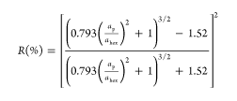ap and ahex are the average diameter of an individual sphere and the average distance of separation of spheres in a close packed surface.
* Where:







Part 3:

* Find the number and size of each uncovered region in 'bad' images
* Counts how many times there are double layers (a sphere above the base layer)
* Characterise images by size of grains - number of hexagon groups, or triangular groups.

Moth eye SEM images

A contour is a closed curve of points or line segments that represents the boundaries of an object in the image. Contours are essentially the shapes of objects in an image.

Unlike edges, contours are not part of an image. Instead, they are an abstract collection of points and line segments corresponding to the shapes of the object(s) in the image.

We can use contours to count the number of objects in an image, categorize objects on the basis of their shapes, or select objects of particular shapes from the image.

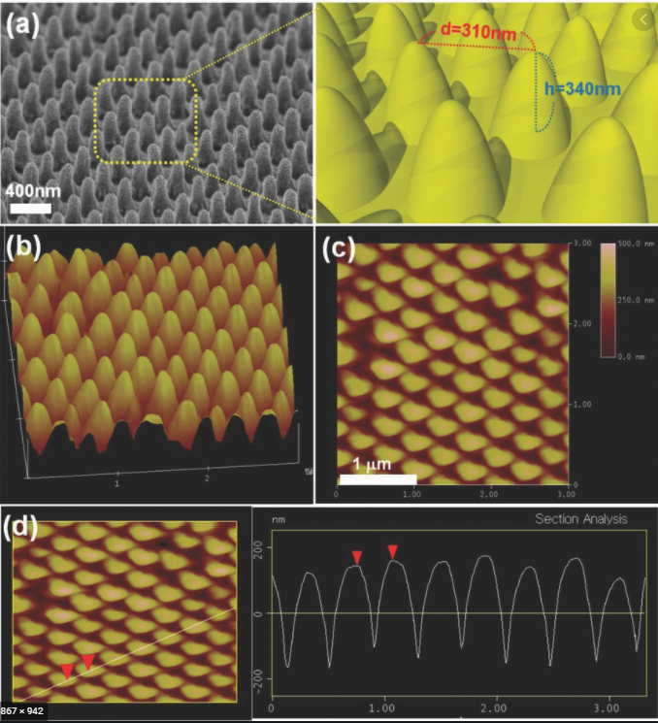

Moth eye textured diamond

OPencv

Filtering

https://ivpl.northwestern.edu/wp-content/uploads/2019/02/Digital-Signal-Processing-Handbook.pdf

Median filter – The median statistic was described in section 51.3.5. A median filter is based on moving a window over an image (as in a convolution) and computing the output pixel as the median value of the brightnesses within the input window. If the window is J ×K in size we can order the J • K pixels in brightness value from smallest to largest. If J • K is odd, then the median will be the (J • K + 1)/2 entry in the list of ordered brightnesses. Note that the value selected will be exactly equal to one of the existing brightnesses so that no roundoff error will be involved if we want to work exclusively with integer brightness values. T

Thresholding is the simplest method of image segmentation. It is a non-linear operation that converts a gray-scale image into a binary image where the two levels are assigned to pixels that are below or above the specified threshold value. In other words, if pixel value is greater than a threshold value, it is assigned one value (may be white), else it is assigned another value (may be black

Fourier transform

Notice the concentric ring structure in the FT of the white pellets image. It is due to each individual pellet. That is, if we took the FT of just one pellet, we would still get this pattern. Remember, we are looking only at the magnitude spectrum. The fact that there are many pellets and information about exactly where each one is is contained mostly in the phase. The coffee beans have less symmetry and are more variably colored so they do not show the same ring structure. You may be able to detect a faint "halo" in the coffee FT

The result shows that the image contains components of all frequencies, but that their magnitude gets smaller for higher frequencies. Hence, low frequencies contain more image information than the higher ones. The transform image also tells us that there are two dominating directions in the Fourier image, one passing vertically and one horizontally through the center. These originate from the regular patterns in the background of the original image.

Low frequencies correspond to the slowly varying components of an image ¬ High frequencies correspond to fast gray level changes in the image (edges, noise…)

Discussion

Blob detetion and processing

<https://www.linkedin.com/pulse/blob-detection-satellite-imagery-using-opencv-andrew-cutts/>

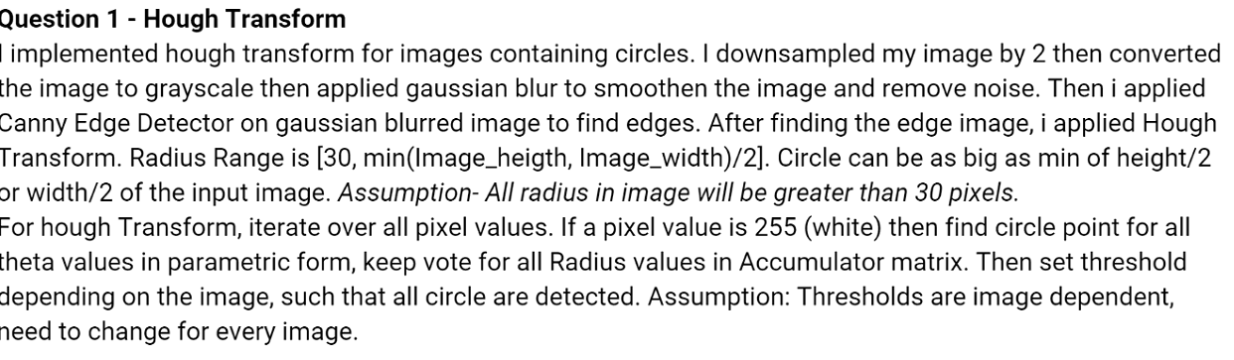

Opencv functions

The image is first readn and converted into coloour by the fucntoin

cv2.cvtColor

which converts first to coulour to find threshold then to gray scale

# Hough Circle Transform

A circle is represented mathematically as



 where

 is the center of the circle, and

 is the radius of the circle. From equation, we can see we have 3 parameters, so we need a 3D accumulator for hough transform, which would be highly ineffective. So OpenCV uses more trickier method, **Hough Gradient Method** which uses the gradient information of edges.

Need to segment mutualy touching objects

Any grayscale image can be viewed as a topographic surface where high intensity denotes peaks and hills while low intensity denotes valleys. You start filling every isolated valleys (local minima) with different colored water (labels). As the water rises, depending on the peaks (gradients) nearby, water from different valleys, obviously with different colors will start to merge. To avoid that, you build barriers in the locations where water merges. You continue the work of filling water and building barriers until all the peaks are under water. Then the barriers you created gives you the segmentation result. This is the “philosophy” behind the watershed. You can visit the [CMM webpage on watershed](http://cmm.ensmp.fr/~beucher/wtshed.html) to understand it with the help of some animations.

But this approach gives you oversegmented result due to noise or any other irregularities in the image. So OpenCV implemented a marker-based watershed algorithm where you specify which are all valley points are to be merged and which are not. It is an interactive image segmentation. What we do is to give different labels for our object we know. Label the region which we are sure of being the foreground or object with one color (or intensity), label the region which we are sure of being background or non-object with another color and finally the region which we are not sure of anything, label it with 0. That is our marker. Then apply watershed algorithm. Then our marker will be updated with the labels we gave, and the boundaries of objects will have a value of -1.

For finddning location with template matching in opencv

<https://opencv-python-tutroals.readthedocs.io/en/latest/py_tutorials/py_imgproc/py_template_matching/py_template_matching.html#template-matching>

**FFT of an image meaning**

These computer simulations demonstrate that the Fourier representation encodes image information in a holistic distributed manner that allows manipulation of the global information content of the image by spatial manipulations of the transformed image.

So like a 1d wave, that can be represented as a sum of sines and cosines, any 2d image can be represented (loosely speaking) as a sum of "rotated sines and cosines", as shown above.

when we take fft of a image in opencv, we get weird picture. What does this image denote?

It denotes the amplitudes and frequencies of the sines/cosines that, when added up, will give you the original image.

n the images I've shown, the highest frequency is in the center of the image, lowest frequency (i.e. the mean of the input image) is top left pixel in the FFT result. That's what most FFT implementations give you. If you display the FFT result, it's common to move the lowest frequency to the center of the displayed image

ourier analysis is used in image processing in much the same way as with one-dimensional signals. However, images do not have their information encoded in the frequency domain, making the techniques much less useful. For example, when the Fourier transform is taken of an audio signal, the confusing time domain waveform is converted into an easy to understand frequency spectrum.

In comparison, taking the Fourier transform of an image converts the straightforward information in the spatial domain into a scrambled form in the frequency domain. In short, don't expect the Fourier transform to help you understand the information encoded in images.

t is not desirable to perform a matching procedure inall three color spaces [14]. Therefore the RGB signal isconverted into the luminance (Y). In this research we per-form the stereo matching algorithm only on the intensity(Y) of the input signals

**Further extension by suing defect detection algorithm**

https://projet.liris.cnrs.fr/imagine/pub/proceedings/ICIP-2014/Papers/1569911795.pdf

DEfect detection is  a relevant area of extension for this application. Appearance of defects, and their determination for manufactured small scale devices that require non-invasive and easily implementable.

A short coming of the method was that it was limited in the ability to filter noise completely or robustly. SApecialised alogorithms, such as ....... are shown to be sucessfully applied in cases of determinining small feature defects and filtering noise.

Further:

Adaptive thresholding

https://www.bogotobogo.com/python/OpenCV_Python/python_opencv3_Image_Global_Thresholding_Adaptive_Thresholding_Otsus_Binarization_Segmentations.php